ASSIGNMENT 4

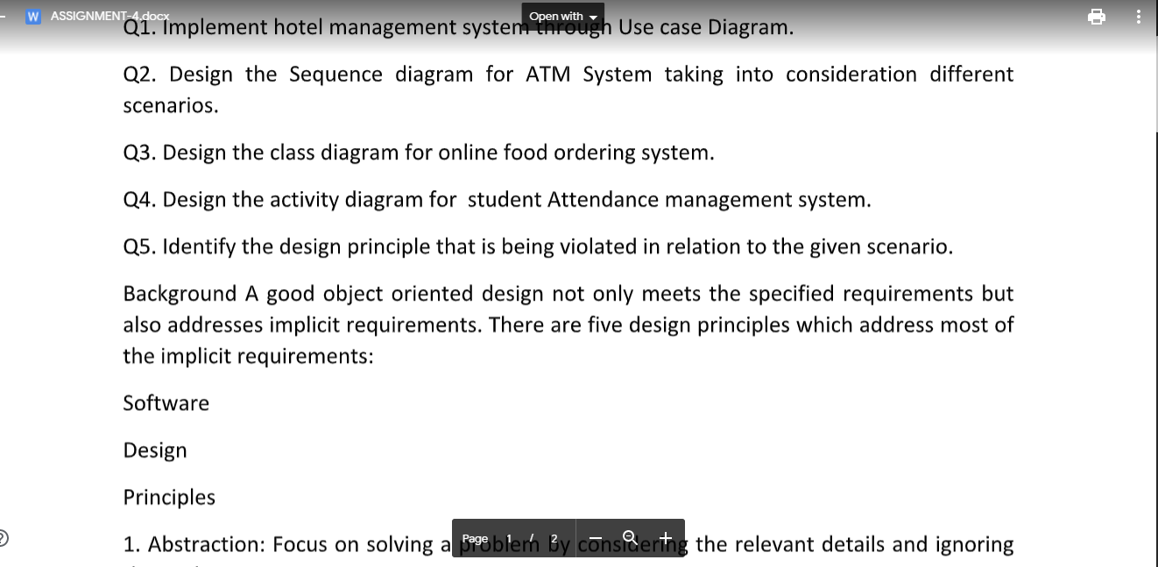

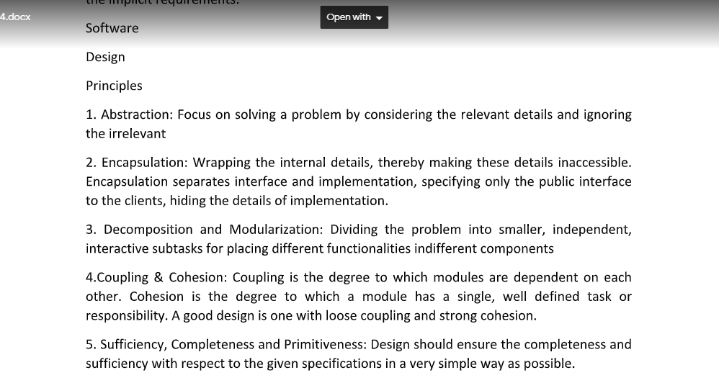

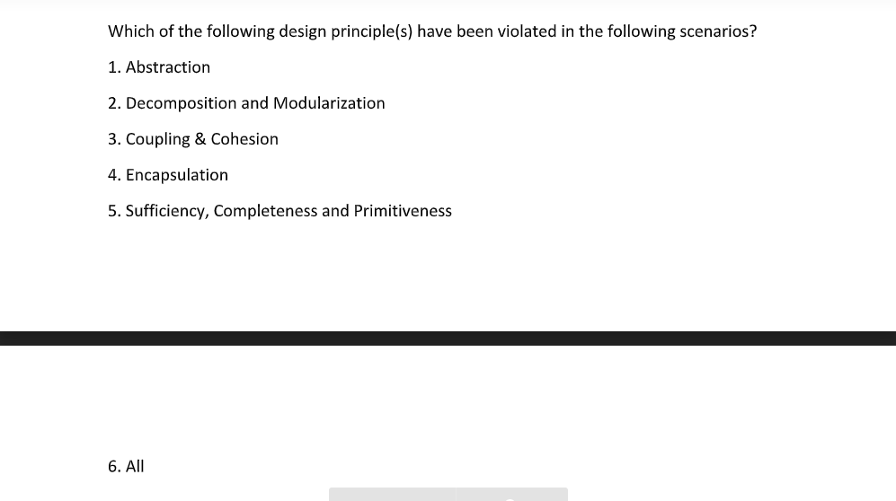

Q1. Implement hotel management system through Use case Diagram.

Solution:-

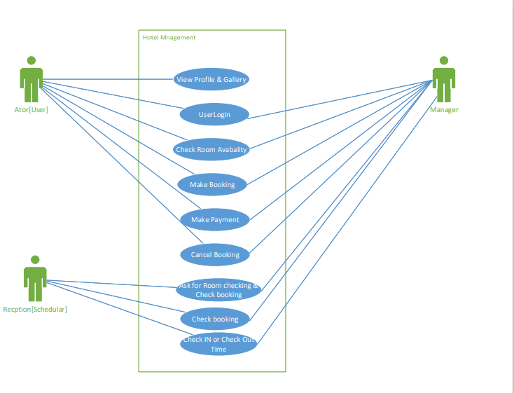

Q2. Design the Sequence diagram for ATM System taking into consideration different

scenarios.

Solution:-

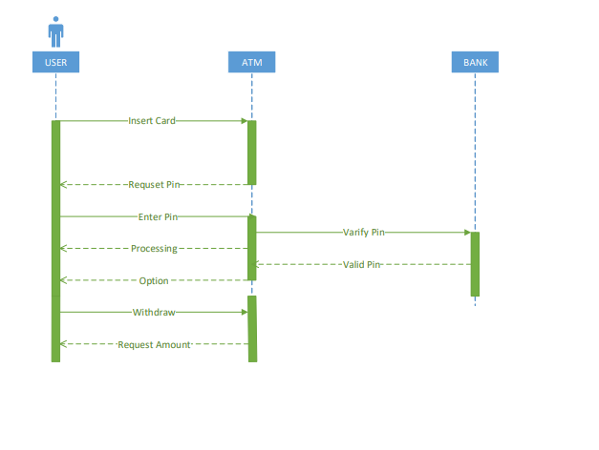

Q3. Design the class diagram for online food ordering system.

Solution:-

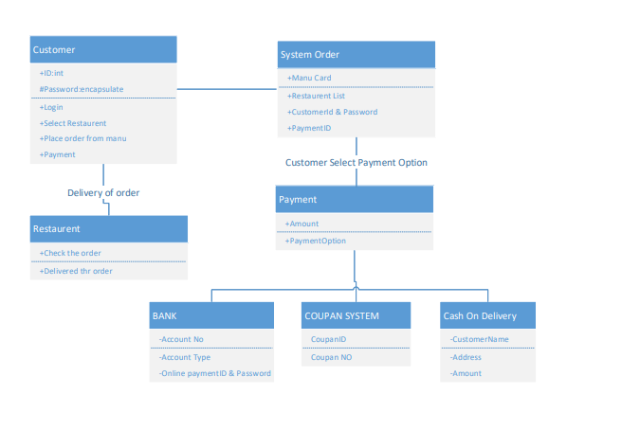

Q4. Design the activity diagram for student Attendance management system.

Solution:-

